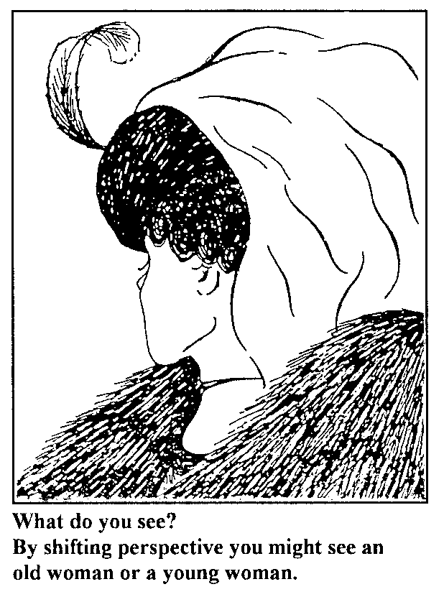
Name _________________________________________________ Per. ___________
Chapter 2: “Paradigms and Principles”
Core Skill: Writer’s Purpose CCSS RI 8.5
- Why do you think Sean Covey begins his chapter with the “Top 10 All-Time Stupid Quotes?” ______________________________________________________________

Core Skill: Writer’s Craft CCSS RI 8.4
2. Read the following paragraph taken from page 13.
Paradigms are like glasses. When you have incomplete paradigms about
yourself or life in general, it’s like wearing glasses with the wrong prescription.
That lens affects how you see everything else. As a result, what you see is what you
get. If you believe you’re dumb, that very belief will make you dumb. If you believe
your sister is dumb, you’ll look for evidence to support your belief, find it, and she’ll
remain dumb in your eyes. On the other hand, if you believe you’re smart, that belief
will cast a rosy hue on everything you do.

3. Covey begins this paragraph with a simile. Highlight it. What is the effect of using this comparison?
________________________________________________________________________________________________________________________________________________________________

4. Now go back to the paragraph above and circle all the words that further develop the simile. What impact do these words have on the paragraph? _____________________________________________
________________________________________________________________________________

Core Skill: Using Textual Evidence in Writing CCSS W 8.2, 8.9
5. Write a paragraph by completing the template below.
In his ___________________, __________________________________________________, author
______________________________ uses an effective simile to illustrate the point that _____________
_________________________________________________________________________________________________ . To further illustrate this example, Covey explains that,“____________________
__________________________________________________________________________________________________________” (13). This comparison works because _________________________
________________________________________________________________________________ .
It also adds the effect of _______________________________________________________________
_________________________________________________________________. Essentially, Covey’s
clever use of figurative language in this passage helps the reader to better understand that ______________
________________________________________________________________________________

Core Skill: Writing CCSS W 8.2, 8.4, 8.10
6. Choose one of the Baby Steps from page 28 to work on over Winter Break. Write your goal here. _____
________________________________________________________________________________________________________________________________________________________________
7. Write a well-written, multi-paragraph essay about your experience working on that step. The first paragraph should explain why working toward that goal is important to you. The body paragraphs should describe what action you took and what happened in the process. The concluding paragraph should be a reflection of what you learned in the process. This writing assignment is due Jan. 15th (along with 5 AR Points). You may type the essay in Google Docs and share it with me, or you may start in the space below and attach additional paper.
________________________________________________________________________________________________________________________________________________________________________________________________________________________________________________________________________________________________________________________________________________________________________________________________________________________________________________________________________________________________________________________________________________________________________________________________________________________________________________________________________________________________________________________________________________

